# How loud is a string?

## Introduction

I enjoy playing songs on piano. However, I have noticed that while it is easy to play quietly, playing notes louder have always been a challenge. This turned me curious of the relationship between the loudness of the sound and the amount of force that I apply to it.

## Research Question

How does the force use to displace the center of a string affect the loudness of the sound which the string produces?

## Experiment

### Design

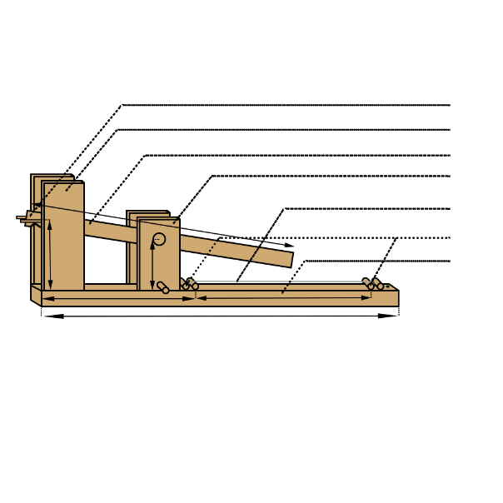

**30 cm**

**5 cm**

**31 cm**

**15 cm**

**55 cm**

**9 cm**

Back Board

Pressure rod

String

First Shelf

Lever

Second shelf

Rubber band holder

*Diagram is not to scale

#### Explaining the measurement

The rubber band holder needs to be 8 cm away from the back board since 8 cm is the length of the rubber band which I am using needs to expand in order to produce 1N of force. While there may be pressure rods levels the string up by 1 cm, the rubber band holder’s position would not be affected since the rubber band would have released all of its force by less than 4 cm. The rubber band holder help

Since the rubber band holder is 8 cm above the backboard and 7 cm above the string, and the distance between the right most pressure rod and the right end of the back board being 15 cm, the lever needs to be 31 cm. This way, it forms a right-angled triangle with base 30, causing it to extend 15cm beyond the pressure rod, which causes the lever to contact exactly the middle of the string. This is important since the theoretical model depends of the string being struck in the center, or else a different equation would be needed to predict the results

Two pressure rods are used to level the string above the back board so that there are room for the string to bend. It also helps to keep the ends of the string stable. This is important vibration at the end of the string will cause energy to escape away from the system, which is not accounted for in the model which I have constructed.

### Procedure

First, I adjusted the turned the adjusting knob until the string lied straight but have no tension. I then turned the knob an extra 180 degrees to add extra tension onto the string. The knob keeps the string in place, and maintains a constant tension. This is important since the tension on the string is a variable directly involved in the theoretical relationship between force striking the string and the loudness of the sound produced, and any changes in the tension will cause changes in the result.

I then moved into a quiet room to reduce background sound., since any background noise will directly increase the loudness recorded by the microphone, and thus make the results inaccurate. The microphone I used was also set to the minimum gain to minimize the effects of recording background noise.

After, I placed the microphone as close to the middle of the string as possible to avoid intensity lost from the distance sound travels. I then attached the microphone to my computer and started recording with audition.

I attached one rubber band onto the holder and the end of the lever. I pressed the lever down to the bottom and released it five times (each time with new rubber bands) to gather five sets of results for the loudness produced by one rubber band. I then repeated the process from recording to pressing the lever for 2, 3, 4, 5, 6, 7, and 8 rubber bands, each one with five trials, and every trial using new rubber bands. This is importance since rubber band will lose Elasticity after use, which will cause changes in the actual amount of force used to strike the guitar string, and thus effect the results.

## Hypothesis

### Variables

|  |  |  |  |  |
| --- | --- | --- | --- | --- |
| Variable | Meaning | Unit | Value | Method of obtain |
| $$I$$ | Intensity | $$W/{m^{2}}$$ | Variable | Calculate |
| $$p$$ | Average sound pressure | $$Pa$$ | Variable | Calculate |
| $$v$$ | Average particle velocity | $$m/s$$ | Variable | Calculate |
| $$ω$$ | Angular frequency | $${rad}/s$$ |  | Calculate |
| $$a$$ | Amplitude (particle displacement) | $$m$$ | Variable | Calculate |
| $$μ$$ | Density of medium in which sound is traveling | $${kg}/{m^{3}}$$ | $$1.225±0.0005$$ | Research online  (Engineering Toolbox, 2003) |
| $$c$$ | Speed of wave (sound) | $$m/s$$ | $$343±0.5$$ | Research online  (Serway, 2000) |
| $$f$$ | frequency | $$Hz$$ | $$441±2.0$$ | Computer measure |
| $$π$$ | Ratio of circumference to diameter of a circle | **N/A** | $$3.1415927±1.6{×10}^{-6}\%$$ | Research online |
| $$n$$ | Ratio of the particle velocity to the product of angular velocity and particle displacement | **N/A** | $$37±2$$ | Measure |
| $$F_{t1}$$ | Original tension of the string | $$N$$ | $$58±0.1$$ | Force meter measure |
| $$F_{t2}$$ | Tension of the string at equilibrium | $$N$$ | Variable | Calculate |
| $$F_{a}$$ | Force of the striking object | $$N$$ | Variable | Control |
| $$F_{v}$$ | Vertical component of the tension of the string | $$N$$ | Variable | Calculate |
| $$x_{1}$$ | Change in length of string with tension applied |  |  |  |
| $$x_{2}$$ | Change in length of string with tension and striking force applied | $$m$$ | Variable | Calculate |
| $$k$$ | Spring constant of the string | $$N/m$$ | $$1847±0.5$$ | Calculate |
| $$l_{o}$$ | Original length of the string | $$m$$ | $$0.3±0.001$$ | Ruler measure |
| $$l_{n}$$ | Length of the string when struck by the jack | $$m$$ | Variable | Calculate |
| $$p_{ref}$$ | Reference sound pressure of the microphone | $$Pa$$ | $$120±1.0×{10}^{-8}$$ | Manufacturer information  (Blue, 2017) |
| $$p_{rms}$$ | Root mean square of the amplitude of the recording | $$Pa$$ | Variable | Calculate |
| $$p_{dB}$$ | Sound pressure measured by the microphone | $$dB SPL$$ | variable | Microphone record |

**Note**: uncertainty of digital instrument is the smallest unit of measurement. constants are treated as analogue instrument measurements, and have uncertainty of half of the smallest unit of measurement.

### Deriving the formula

#### General equation

The loudness of sound is determined by its intensity, which have the formula definition of $I=pv$, (smith, 2010)

The average intensity for sound wave can be described with: $I=\frac{1}{2}ω^{2}a^{2}μc$ (Sengpiel, 2009)

Since both equations describes the average sound intensity, they can be used to form an equation: $pv= \frac{1}{2}ω^{2}a^{2}μc$

Since angular frequency is just change in angle per second, it can be represented as: $ω=2πf$

Plugging this back into the equation, intensity now becomes: $I=\frac{1}{2}ω^{2}a^{2}μc=\frac{1}{2}{{(2πf)}^{2}a}^{2}μc={2π^{2}f^{2}a}^{2}μc$

#### Average sound pressure

The average sound pressure level is best represented by the root mean square of the amplitude of sound pressure.

I have measured the sound pressure using a microphone, which returns a decibel value using the fallowing formula: $p_{dB}= 20\log\left(\frac{p_{rms}}{p_{ref}}\right)dB$. (Lewis, 2012)

By rearranging the variables, the formula becomes: ${ p}_{rms}={10}^{\frac{p_{dB}}{20}}×p_{ref}$

#### Particle velocity

As $v∝ωa=2πfa$, therefore: $v$ can be expressed as $v=2πfan$, with $n$ as a constant.

#### Amplitude of particle displacement

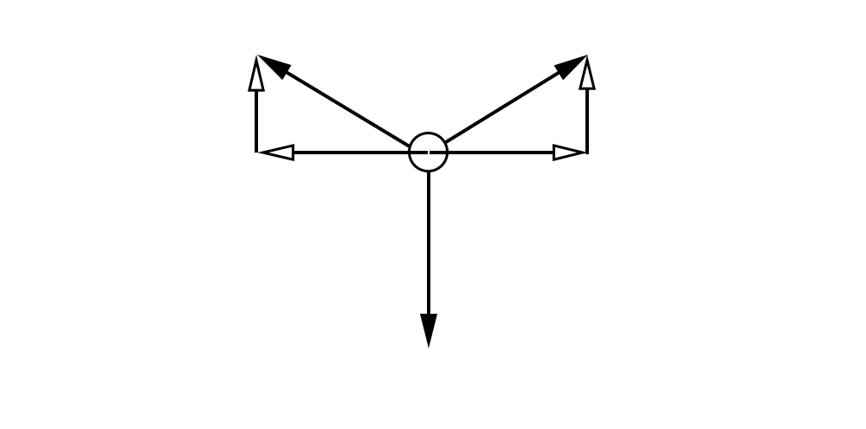

The amplitude is related to the tension force and the force pushing the string:

At the maximum displacement, the system would be in equilibrium, as seen from the free body diagram. In order to balance the vertical forces, ${2×F}_{v}=F_{a}$

Therefore, according to Pythagorean theorem: $F_{t2}=\sqrt{{F_{t1}}^{2}+{(\frac{F_{a}}{2})}^{2}}$

Since $F_{t2}$ will be the final force on the string, according to hook’s law, the string will extend $x=\frac{F_{t2}}{k}=\frac{\sqrt{{F_{t1}}^{2}+{(\frac{F_{a}}{2})}^{2}}}{k}$ m

In this diagram, $l_{n}$ shows the position of the string after being struck while $l_{o}$ shows the string before it was struck.

As preciously concluded, $l_{n}=\frac{l_{o}+x}{2}$ since all the force are used turned into tension at equilibrium.

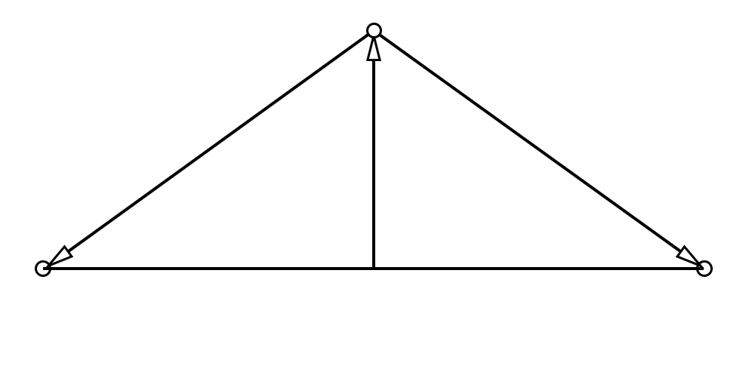

Therefore, according to Pythagorean theorem: $a^{2}={l_{n}}^{2}-{\left(\frac{l_{o}}{2}\right)}^{2}$

Plugging in the values: $a=\sqrt{{\left(\frac{l_{o}+x_{2}}{2}\right)}^{2}-{\left(\frac{l_{o}+x_{1}}{2}\right)}^{2}}=\sqrt{{\left(\frac{l_{o}+\frac{\sqrt{{F_{t1}}^{2}+{\left(\frac{F_{a}}{2}\right)}^{2}}}{k}}{2}\right)}^{2}-{\left(\frac{l_{o}+\frac{F_{t1}}{k}}{2}\right)}^{2}}=\frac{\sqrt{{(l_{o}k+\sqrt{{F_{t1}}^{2}+{(\frac{F_{a}}{2})}^{2}})}^{2}-{(l_{o}k+F_{t1})}^{2}}}{2k}$

#### Substituting into original equation

$${2π^{2}f^{2}a}^{2}μc= pv=\left({10}^{\frac{p_{dB}}{20}}×p_{ref}\right)∙\left(2πfan\right)$$

After simplifying and rearranging, the formula becomes: $\frac{πfaμc}{n}={10}^{\frac{p_{dB}}{20}}×p_{ref}$

Now plug in the amplitude, and we get the final equation: $\frac{πf\sqrt{{(l_{o}k+\sqrt{{F_{t1}}^{2}+{(\frac{F_{a}}{2})}^{2}})}^{2}-{(l_{o}k+F_{t1})}^{2}}μc}{2kn}={10}^{\frac{p_{dB}}{20}}×p_{ref}$

From this equation, it can be seen that the relationship between the vibration amplitude and the measured loudness is a logarithmic since the measured loudness is measured in decibels.

The amplitude of particle displacement is proportional to the sound intensity of the sound, as these two variables appear on each side of the equation with the same exponent of one.

Also, it can be seen that the particle is mostly proportional to the force used to strike the string, as the squares and roots out side of the striking force cancels each other out. However, since there are other constants involved in the process, the proportional relationship is only an approximation.

### Hypothesis

As the force striking the string increase, the microphone’s recorded loudness will experience a logarithmic increase. This is because that the force will proportionally cause the string to expand a certain length, which causes the change in the amplitude of the particle displacement, which then proportionally increases the sound pressure, which is recorded using a logarithmic scale on the computer to generate the recorded loudness.

## Data Analysis

### General

#### Uncertainty

This is the formula which I will be using to calculate the uncertainty: $u_{total}=u_{human}+u_{formula}$ or $u_{total}=u_{human}+u_{measurement}$

The human uncertainty will be determined by the difference between the average and the maximum and minimum values in the data set: maximum difference will be the positive uncertainty and minimum difference will be the negative uncertainty

The formula uncertainty is for the consideration of the uncertainty of the constants used in my model, which gives the equation uncertainties. This uncertainty will only be performed when the data involves calculation from my equation, and this uncertainty takes the measurement uncertainty into account, since the measurement is part of the formula.

Since Audition measures the loudness in dB up to 2 decimal places, the measurement uncertainty would always be $±0.01$

### Raw Data

#### Table 1:

##### Table of microphone recorded loudness (dB SPL) depending on forces applied (N)

|  |  |  |  |  |  |  |  |  |
| --- | --- | --- | --- | --- | --- | --- | --- | --- |
| # of rubber bands | 1 | 2 | 3 | 4 | 5 | 6 | 7 | 8 |
| Force applied (N) | 1 | 2 | 3 | 4 | 5 | 6 | 7 | 8 |
| Trial 1 (dB) | -19.85 | -14.95 | -13.57 | -16.58 | -11.23 | -8.83 | -8.89 | -7.58 |
| Trial 2 (dB) | -16.84 | -18.50 | -13.94 | -11.61 | -10.93 | -8.85 | -7.17 | -6.10 |
| Trial 3 (dB) | -18.38 | -17.82 | -15.49 | -14.32 | -13.72 | -8.90 | -11.15 | -6.95 |
| Trial 4 (dB) | -21.05 | -17.65 | -17.69 | -14.15 | -9.91 | -12.07 | -7.49 | -6.35 |
| Trial 5 (dB) | -23.30 | -15.78 | -12.86 | -10.08 | -11.57 | -9.72 | -7.77 | -7.52 |
| Trial 6 (dB) | -19.67 | -15.16 | -14.69 | -13.02 | -11.89 | -11.16 | -11.00 | -6.95 |
| Trial 7 (dB) | -19.43 | -21.17 | -17.73 | -14.63 | -11.57 | -11.63 | -8.58 | -4.73 |
| Trial 8 (dB) | -21.08 | -20.29 | -16.83 | -10.77 | -11.85 | -19.83 | -9.74 | -7.73 |
| Trial 9 (dB) | -22.27 | -17.22 | -14.64 | -15.68 | -10.15 | -9.58 | -8.81 | -7.11 |
| Trial 10 (dB) | -20.29 | -17.15 | -18.04 | -11.70 | -13.76 | -11.23 | -8.68 | -6.16 |
| Trial 11 (dB) | -22.72 | -18.56 | -14.92 | -11.79 | -10.77 | -12.29 | -9.17 | -7.45 |
| Trial 12 (dB) | -19.28 | -16.33 | -16.06 | -13.66 | -10.56 | -8.34 | -8.73 | -8.23 |
| Trial 13 (dB) | -21.61 | -18.22 | -18.40 | -16.58 | -9.69 | -12.05 | -9.95 | -7.21 |
| Trial 14 (dB) | -19.20 | -17.26 | -14.20 | -14.62 | -10.23 | -10.77 | -7.87 | -7.12 |
| Average (dB) | -20.69 | -17.58 | -15.65 | -13.51 | -11.27 | -10.38 | -9.00 | -7.01 |

#### Data calculation:

Force: Since each rubber band stores 1 N of force, the amount of force striking the string would be equal to the amount of rubber band used.

Loudness: the loudness is kept as their original value since this is the raw data table: they will be processed later.

#### Uncertainty Calculation

$$u_{total}=u_{human}+u_{measurement}$$

##### Sample calculation (1N):

**Measurement uncertainty (Y):**

**Human uncertainty (Y):**

Min: $\left|20.69-23.30\right|=2.61$ Max: $\left|20.69-16.84\right|=3.85$

**Total uncertainty (Y):**

Min: $2.61+0.29+0.01=2.91$ Max: $3.85+0.29+0.01=4.15$

**Uncertainty (X)**

The uncertainty for the force of each rubber band is $±0.1N$

Therefore, the uncertainty for one rubber band will be $±0.1∙1=±0.1N$

**Table of the uncertainties for graph 1**

|  |  |  |  |  |
| --- | --- | --- | --- | --- |
| Force | Loudness (dB) | Y max uncertainty (dB) | Y min uncertainty (dB) | X uncertainty (N) |
| 1 | **-20.69** | 2.31 | 3.65 | 0.1 |
| 2 | **-17.58** | 2.63 | 3.69 | 0.2 |
| 3 | **-15.65** | 2.79 | 2.75 | 0.3 |
| 4 | **-13.51** | 3.07 | 3.33 | 0.4 |
| 5 | **-11.27** | 1.91 | 2.14 | 0.5 |
| 6 | **-10.38** | 1.58 | 2.49 | 0.6 |
| 7 | **-9** | 1.83 | 2.15 | 0.7 |
| 8 | **-7.07** | 0.91 | 1.22 | 0.8 |

#### Graph

This graph shows increase in loudness of the audio as the force striking the string increases. My theory proposes that the curve of best fit in this situation would be a logarithmic function, which fits the data well. The points come from the average of all the audio data, which is from the table of microphone recorded loudness (dB SPL) depending on forces applied. The uncertainties come from the table of uncertainties for graph 1.

### Processed data

#### Table

**Table of sound pressure (Pa) depending on Particle displacement**

|  |  |  |  |
| --- | --- | --- | --- |
| Force (N) | Particle displacement (m) | Average loudness (dB) | Sound pressure (Pa) |
| 1 | 0.000439725 | -20.69 | 11.08 |
| 2 | 0.000879427 | -17.58 | 15.96 |
| 3 | 0.001319085 | -15.65 | 18.29 |
| 4 | 0.001758677 | -13.51 | 25.80 |
| 5 | 0.00219818 | -11.27 | 32.77 |
| 6 | 0.002637573 | -10.38 | 36.47 |
| 7 | 0.003076833 | -9.00 | 41.5 |
| 8 | 0.003515938 | -7.07 | 47.1 |

#### Data calculation

The calculations have been carried out using the derived formula.

To linearize the data’s x component, the force has been plugged into the formula representing the amplitude of particle displacement: $\sqrt{{(l_{o}k+\sqrt{{F_{t1}}^{2}+{(\frac{F_{a}}{2})}^{2}})}^{2}-{(l_{o}k+F_{t1})}^{2}}$

To linearize the y component of the data, the loudness in dB have been plugged into the right side of the formula to calculate the sound pressure, which should have a direct relationship to the particle displacement.: ${10}^{\frac{p_{dB}}{20}}×p_{ref}$

##### Sample calculation (1N):

X: $\frac{\sqrt{{(l_{o}k+\sqrt{{F_{t1}}^{2}+{(\frac{F_{a}}{2})}^{2}})}^{2}-{(l_{o}k+F_{t1})}^{2}}}{2k}=\frac{\sqrt{{(0.3∙1847+\sqrt{{58}^{2}+{(\frac{1}{2})}^{2}})}^{2}-{(0.3∙1847+58)}^{2}}}{2∙1847}=4.9×{10}^{-4}m$

Y: ${10}^{\frac{p_{dB}}{20}}×p_{ref}$ = ${10}^{\frac{-20.69}{20}}×120=11.08 Pa$

#### Uncertainty calculation

**Sample Calculation (1N):**

**Human uncertainty (Y):**

Max: ${10}^{\frac{p_{dB}}{20}}×p_{ref}={10}^{\frac{-18.38}{20}}×120=14.46 =>14.46-11.08=3.38 Pa$

Min: ${10}^{\frac{p_{dB}}{20}}×p_{ref}={10}^{\frac{-24.34}{20}}×120=7.28 =>11.08-7.28=3.8 Pa$

**Formula uncertainty (Y):**

Formula: ${10}^{\frac{p_{dB}}{20}}×p_{ref}$

$$=>u_{human}∙\left(±1.0×{10}^{-8}\right)$$

$$=>\left(±3.8\right)∙\left(±1.0×{10}^{-8}\right)$$

$$=>34.3\%+8.3×{10}^{09}\%$$

$$=>(±3.8)$$

Max: $=>u_{human}∙\left(±1.0×{10}^{-8}\right)$

$$=>\left(±3.38\right)∙\left(±1.0×{10}^{-8}\right)$$

$$=>30.5\%+8.3×{10}^{09}\%$$

$$=>(±3.38)$$

The formula uncertainty in this case will be the final uncertainty since the human uncertainty is also taken account for when doing the calculation.

**Formula uncertainty (X):**

Formula: $πf\frac{\sqrt{{(l_{o}k+\sqrt{{F_{t1}}^{2}+{(\frac{F_{a}}{2})}^{2}})}^{2}-{(l_{o}k+F_{t1})}^{2}}}{2kn}μc$

$$=>\left(±5∙{10}^{-7}\right)∙\left(±2.0\right)∙\left(±5∙{10}^{-4}\right)∙\left(±0.5\right)∙(±2)∙\frac{1}{2}∙\left\{\left[\left(±{10}^{-3}\right)∙\left(±20\right)\right]+\frac{1}{2}\left[2∙\left(±0.10\right)+2∙\left(±0.10\right)\right]+2∙\left(±{10}^{-3})∙(±0.01\right)\right\}∙\left(±20\right)$$

$$=>±5.90\%∙\frac{1}{2}∙\left\{\left[\left(±0.33\%\right)+\left(±0.34\%\right)+\left(±20\%\right)\right]+\left(±0.6\%\right)\right\}∙\left(±0.03\%\right)$$

$$=>±5.90\%∙\frac{1}{2}∙\left\{\left(±3.28\right)+\left(±1.35∙{10}^{4}\right)\right\}\left(±0.03\%\right)$$

$$=>(±5.90\%)∙(±\frac{1.59\%}{2})$$

$$=>±6.695\%≈>±2.94×{10}^{-5}m$$

**Note:** rounded numbers are written, but calculation was carried out with all the decimals without rounding.

Each color represents a section of the calculation, and shows how it carries on to the results

steps of transferring percentage and absolute uncertainty have been skipped

**Table of Uncertainties for graph 2**

|  |  |  |  |  |
| --- | --- | --- | --- | --- |
| Particle displacement (m) | Sound pressure (Pa) | X uncertainty | Y max uncertainty | Y min uncertainty |
| 0.000439725 | **11.08** | $$2.94×{10}^{-5}$$ | $$3.884992$$ | $$4.210058$$ |
| 0.000879427 | **15.96** | $$5.89×{10}^{-5}$$ | $$6.361239$$ | $$5.839849$$ |
| 0.001319085 | **18.29** | $$8.83×{10}^{-5}$$ | $$8.459859$$ | $$5.863349$$ |
| 0.001758677 | **25.80** | $$1.18×{10}^{-4}$$ | $$12.00791$$ | $$8.844183$$ |
| 0.00219818 | **32.77** | $$1.47×{10}^{-4}$$ | $$9.499047$$ | $$8.029413$$ |
| 0.002637573 | **36.47** | $$1.76×{10}^{-4}$$ | $$8.777527$$ | $$9.97899$$ |
| 0.003076833 | **41.5** | $$2.06×{10}^{-4}$$ | $$11.83271$$ | $$10.46458$$ |
| 0.003515938 | **47.1** | $$2.35×{10}^{-4}$$ | $$7.947919$$ | $$8.536199$$ |

#### Graph

­

This graph shows the relationship between the particle displacement and sound pressure after applying my theoretical equation on the averaged data points which I have collected. The data points come from the table of sound pressure (Pa) depending on Particle displacement (m).

### Summary

When looking at the table of the original data collected, it can see that the difference between different values are quite high, reaching up to 25% difference from the average many times. This shows that my data collected have relatively low precision. To counter the low precision, I have performed many trials, so that the low precision has minimal effect to the accuracy.

The maximum slope supported by the data set and the uncertainty is 17942, while the minimum slope is 6842. Line of best fit has a slope of 11956. According to my theoretical equation, the slope of after the linearization of the data is supposed to be 15698, which fits within the uncertainty range. When looking at the uncertainty of 43.4% of the slope, it might appear to be a large uncertainty and make the data seem inaccurate, but when the slop is converted to angles, it is only a 0.00525% difference in the actual angle of the lines on the graph. This shows that my final data have relatively high accuracy, as they fit to my theoretical model with a relatively low uncertainty.

## Evaluation

### Safety, environmental and ethic concerns

1. The rubber band might slide off the holder, and hit people around.

Carved a curve into the holder and the jack to keep the rubber band in place.

1. String may snap if under too much tension and hit people in the hand.

Research the maximum tension on the string and make sure that the tension placed on the string does not

exceed the maximum tension capacity of the string.

1. Experiment involve movement of big objects (the jack), and may hit people’s hand if close by.

Make sure that the area of the experiment is clear of people before starting the experiment, and rounded off corners of the jack to minimize damage if there are people within the radius of the jack.

1. Production of the structure involves use of material. Since it is only one-time use, material needs to be recyclable.

Wood is used to build. While it cannot be recycled into a new product, it does not cause harm to the

environment.

### Sources of error

|  |  |  |
| --- | --- | --- |
| Source of error | Significance | Method to improve |
| Constants used for calculation | My calculations involve the string constant for hook’s law, which I found using the Young’s modulus. Since the string is made with a carbon steel core, I used Young’s modulus for high carbon steel to find the spring constant of the guitar string which I am using. However, other materials such as nickel exist in the string, which makes my calculation inaccurate. | Use a string made out of a pure element or have a recorded Young´s modulus. |
| Measuring device | While a professional recording software is used, the computer sound card may have slightly amplified the signal when processing it, causing the reading to be slightly bigger than the real loudness. | Calibrate the computer sound card or use a decibel meter to record the loudness of the sound |
| Structure instability | More than one frequency has been found when analyzing the recorded. This means that not all of the energy generated by the jack have been transferred into one single wave. This causes the actual loudness to be smaller than what the formal predicts. | Leave more room around the wire and connect the components tighter so they do not vibrate together with the string. |
| Structure design | The rubber band holder was held in place on the inner sides of the second shelf. This causes the direction of the forces to be directed towards the sides instead of straight up. This causes the force to be smaller than what they should be according to the design. | Instead of having the rubber band holders on the side, combine them together and place it directly above the end of the lever so that the direction of the force is straight up. |

## Conclusion

Graph 1 shows the relationship of the raw data, which according to the curve of best fit, the data demonstrated a logarithmic relationship, which matches with what my formula predicts. Further more, Graph 2 displays the linearized data, with the maximum and minimum slope as well as a line of best fit. When a line representing the theoretical equation is plugged it, it fits within the maximum and minimum slope. Also, the slope of the theoretical equation is 15698, which fits in the uncertainty range of 17942 to 6842. While this may look like a big difference, when the slopes are converted to angles, it can be seen that it is only a minor 0.00525% difference between the different angels, which is a very small difference. Therefore, Graph 2 also supports my theory.

This experiment aims to find the relationship between the force used to displace the center of a string and the loudness of the amplitude which it produces. This experiment demonstrates that the particle displacement is proportional to the sound pressure of the sound of the string. Since the striking force is roughly proportional to the amplitude of particle displacement at lower amplitudes, which my experiment range is with in, the force would also be proportional to the sound pressure of the sound of the string. However, since all recorders record with the decibel scale, and the logarithmic nature of the decibel scale, the force used to displace the center of the string would have a logarithmic increasing relationship with the volume of the sound recorded. As the experiment demonstrates the logarithmic nature of the raw data, as well as the linear relationship between the amplitude of particle displacement and sound pressure, my experiment successfully proves the relationship between the force used to displace the string and the loudness of the audio recorded by a microphone.

Since human ears function similar to a microphone, and also record loudness in the decibel scale, (Stephane, 2014) the loudness interoperated by human ear should be proportional to the loudness recorded by the microphone, and thus the force striking the string should have a increasing logarithmic relationship. This shows the reason of why playing keys louder on piano is so hard: while the loudness is physically increased proportionally to the increase of force pressing it the human ear uses a logarithmic scale to interoperate the loudness of the sound. Logarithmic functions have a slope approaching to 0 as x approach infinity, which means that the loudness which the ear interoperates will be quieter than the actual loudness at high volumes of sound.

## Work Cited

Air - Density, Specific Weight and Thermal Expansion Coefficient at Varying Temperature and Constant Pressures. (2003). Retrieved from https://www.engineeringtoolbox.com/air-density-specific-weight-d_600.html

Blue. (2017). Yeti. Retrieved from https://www.bluedesigns.com/products/yeti/#

Ir, & Pigeon, S. (2014). The non-linearities of the Human Ear. Retrieved from https://www.audiocheck.net/soundtests_nonlinear.php

Jerad Lewis Download PDF. (2002, May). Understanding Microphone Sensitivity. Retrieved from https://www.analog.com/en/analog-dialogue/articles/understanding-microphone-sensitivity.html

Sengpiel. (2004, September). Zusammenhang der akustischen Größen (Schallgrößen) bei ebenen fortschreitenden Schallwellen. Retrieved from http://www.sengpielaudio.com/RelationshipsOfAcousticQuantities.pdf

Serway. (n.d.). Speed of Sound in Various Bulk Media. Retrieved from

http://hyperphysics.phy-astr.gsu.edu/hbase/Tables/Soundv.html

Smith, J. O. (2010). Acoustic Intensity. Retrieved from https://ccrma.stanford.edu/~jos/pasp/Acoustic_Intensity.html